**ENDPOINTS AND TOKEN IN GRAFANA**

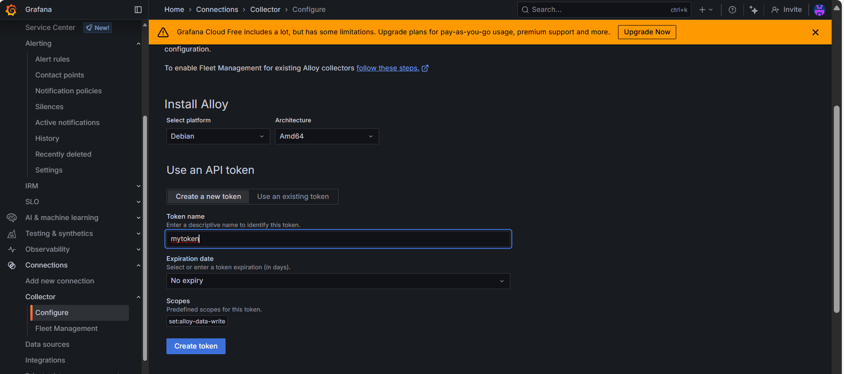

When u click on create token u will be getting token and the end point.

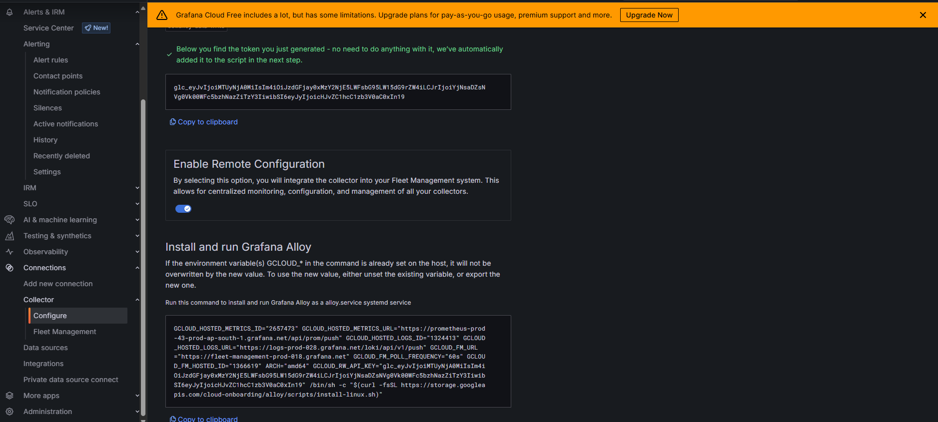

**APP DYNAMICS OPENTELEMETRY CONFIGURATION:**

1. Click einstein

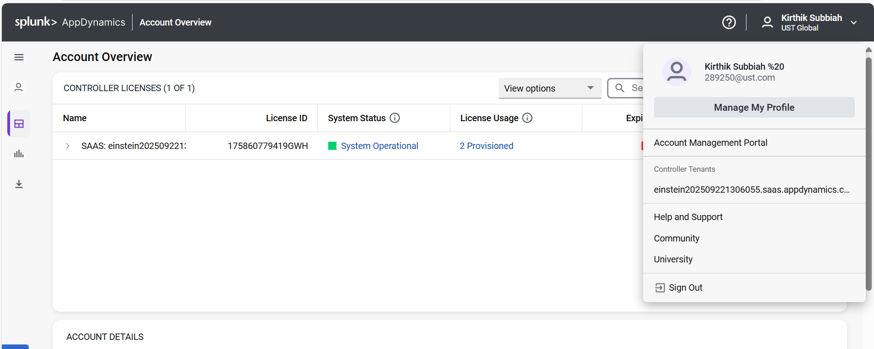

1. Click otel

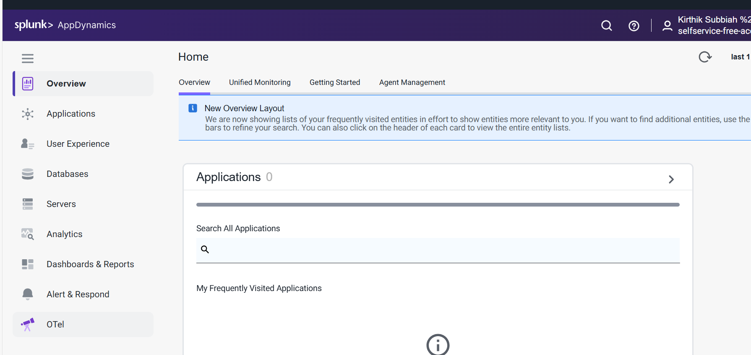

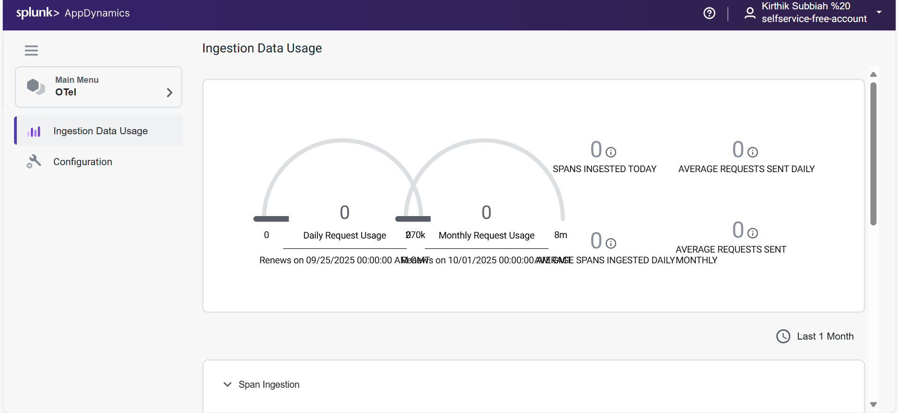

1. Click configuration u will be getting the yaml.

